SETHUMON MADHU



 About Me
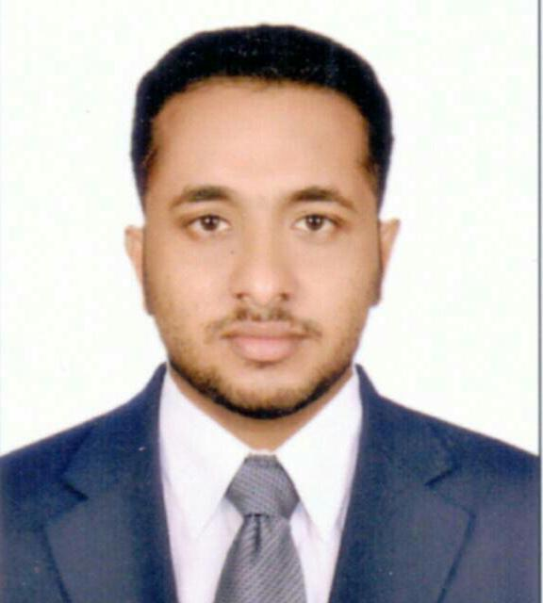

7 Years experience 

May 09, 1993  Kochi, Kerala, India

+91-8921432541
sethumonmadhu.sm93@gmail.com Passport NO: P0101417

 Career Objective

⇨ A performance-driven sales professional with 7 years of total experience in the sales of Edtech, IT & Telecom,
⇨ Expertise in Account Management, Business Development and Marketing
⇨ Strong IT Solutions sales expertise with a large set of customers across multiple verticals.
⇨ Good communication, inter-personal & relationship management skills.
⇨ Adept in analysing the information system needs & evaluating end-user requirements.



Areas of Expertise

Account Management:

- Developing relationships with key institutions in target organizations for business development.
- Manage, delegate, and liaise with internal team to complete the sales cycle.
B2B Sales & Marketing:

- Developing marketing plans for SMB& generate sales from the same.
- Doing digital marketing from LinkedIn, cold calling, email marketing , search engines to generate leads
- Analyzing & reviewing customer’s response/ requirements and taking sales cycle to next level.
- Executing competitor analysis by keeping abreast of market trends and competitor moves to achieve market share metrics.

Corporate Sales:

- Presenting product offerings and architecture in best light to prospective customers.
- Explaining product features and services to companies.
- Removing all objections in the sales cycle and supporting pre-sales efforts. Understanding the needs of clients and translating those needs into a demonstration of functional capabilities.

Business Development

- Identifying potential customers and opportunities through Omni-channel sources.
- Utilize the public information and personal network to develop marketing intelligence for generating leads.
- Identify and develop new streams for long-term revenue growth and maintaining relationships with customers to achieve repeat/ referral business.


Work Experience

Assistant Manager-Enterprise Business July 2024-till
Reliance Jio Infocomm Ltd Kochi, Kerala.

- Identifying and acquiring new customers, as well as up-selling to the existing customer base across the region
- Drive small and medium enterprise business in the assigned territory
- Work with cross functional teams to coordinate pre-sales, post-sales and support resources to drive successful closure and implementation for customers
- Using knowledge of the market and competitors, identify and develop the company’s unique selling propositions and differentiators
- Maintain excellent relationships within the customer organization for up-selling and cross selling.
- Manage strategic accounts, maintain, and retain those high value customers to keep a long-term relationship and improve customer satisfaction.

Regional Customer Manager March 2023 – July 2024
Jarulss Software Solutions Pvt Ltd Kochi, Kerala.
Projects: Power School + Neverskip

Job Responsibilities:

- Identifying and acquiring new customers, as well as up-selling to the existing customer base across the region
- Developing & implementing sales strategies and plans to meet revenue goals
- Maintain and provide strength to company’s brand position in assigned regional marketing area.
- Generate price quotes, proposals, bids etc, along with pre-sales team.
- Maintain excellent relationships within the customer organization for up-selling and cross-selling.
- Manage strategic accounts, maintain, and retain those high value customers to keep a long- term relationship and improve customer satisfaction.
- Providing necessary training to the newly joined recruits and allocate work to them

Sales Manager Sep 2018 – Dec 2022
Queen Auto Spare Parts LLC Dubai
- Identifying and acquiring new customers, as well as up-selling to the existing customer base across the region.
- Developing & implementing sales strategies and plans to meet revenues goals.
- Maintain excellent relationships with in the customer organization tie up selling and cross-selling.
- Manage strategic accounts,maintain,and retain those high value customer stoked along-term relationship and improve customer satisfaction.
- Interact with marketing leads to develop and supervise regional marketing budget
Business Development Manager June 2017 – July 2018

Fireco (Engineering Consultant & Constructor ) Kottayam, Kerala.
Job Responsibilities:

- Creating development plans and forecasting sales targets and growth projections.
- Identifying market opportunities through meetings, networking and other channels.
- Meeting existing and potential clients and building positive relationships.
- Liaising with colleagues to develop sales and marketing strategies.
- Preparing financial projections and sales targets.
- Preparing sales presentations and participating in sales meetings.
- Producing reports for management.
- Training business developers and sales colleagues.
- Working in a client’s business or in an office.

 Education
BE. Mechanical Engineering Graduated, Apr 2016
JKK Munirajah College of Technology Marks 68%
Anna University Board Erode, Tamilnadu

Higher Secondary school Graduated, Mar 2011
S.K.M HSS,Kumarakom Marks 81% State Board, Kerala

SSLC Graduated, Mar 2009
S.K.M HSS,Kumarakom Marks 72% State Board, Kerala

 Technical Skills
- Platforms
- Packages

: Microsoft Windows XP/2003/2007, VISTA.
: .NET 4.0, Visual Studio 2010 &MS-Office,Zoho


Personal Details
Father’s Name : | Mr. T.K Madhu | Marital Status : Single
Religion : | Hindu | Nationality : Indian
Gender :  Language known : | Male  English, Malayalam, Tamil, Hindi &Arabic

Declaration
I, Sethumon Madhu, hereby declare that the information contained herein is true and correct to the best of my knowledge and belief.

SETHUMON MADHU

